Executive Summary: Exploratory Data Analysis “House Price”
- Overview and purpose
The dataset contains residential negotiation by considering complex multidimensional factors beyond number of bedrooms or location. This Exploratory Data Analysis (EDA) investigates the 79 features across 1,460 home sales to evaluate the data distribution, identify missing data structure and evaluate intercorrelations, using the price sales as a variable of interest and determinate how is influenced by the rest features.
- Data description
The data set contains 1,460 observations (houses) and 81 features (38 numerical and 43 categorical variables).
A missing data analysis was performed, identifying missing values in 19 variables. Foues features exhibit higher number of missing data: PoolQC (99.52%), MiscFeature (96.30%), Alley (93.77% and Fence (80.75%) (Figure 1 and 2). A domain analysis confirms that those missing values reflect the absences of the features rather than collection error. Additionally, few features show moderate absence of data, such as FireplaceQu(47.26%), LotFrontage (17.73%) and Garage features (<5%) displaying insignificant impact.
- Methodology

  - Univariate Distribution Analysis
Summary statistic (Mean, Median, SD, IQR) and Kernel Density Estimation (KDE), histograms were generated to assess the skewness and non-normality of metric. Count plot was used for ordinal features.
Statistical evaluation reveals strong right-skewness across several variables (Figure 3)
- Sale Prices (SalePrice): Ranges from $34, 900 to $755,000, with a median of $163, 000 (Q1 $163, 000.0 and Q3 $214,000.00). The means is around $180,921, elevated value compared to the median due to the upper luxury outliners.
- Above-Grade Living Areas (GrLivArea): Displays a matching right-skewed shape ranging from 334 sq ft to 5,642 sq ft. (Median: 1464 sq ft, Q1= 1,129 sq ft and Q3= 1,776.75 sq ft) notable outliers beyond the 3,000 sq ft.
- Overall Quality ( OverallQual): Ordinal ratings (1 – 10) houses clustered around rank 5 (395 homes) and 6 (375 homes), stablishing the middle value market. (Figure 4)
  - Correlation matrix and bivariate analysis.
A Person Correlation Coefficients (r) were calculated across numerical variables and build and heatmap, identifying primary linear associations.
  - Outlier detection
Scatterplots and boxplots were constructed to evaluate bivariate linear relationship and detected noticeable outlier.
Bivariate Analysis and core price drivers
A correlation matrix was performed (Figure 5) considering “Sale Price” as the independent variable, highlighting these findings:
Variable | Metric description | correlation (r) | key finding
Overall Quality | Overall Material and Finish Rating | r= 0.79 | Exponential price growth from rank 5 upwards. Upper outliers from rank 5 to 8, meaning that high-quality finish significantly boosts the house valuation, (Figure 6)
Grlivarea | Above-grade Living Space (sq ft) | r=0.71 | Strong linear trend: highlight 2 lower-right partial outliers, showing properties sold for low prices compared to the rest of the houses. (Figure 7)
Garage Cars /Garage Area | Cagara Capacity and Total Size | r= 0.64 / 0.62 | Peek valuation at 3, significant drop in the median value at 4-car capacity indicating that those properties are old or customized. (Figure 8)
TotalBsmtSF / 1stFlrSF | Basement & 1st floor square feet | r= 0.61 / 0.61 | Direct structural correlation with total above-ground living area.

Geographic evaluation across neighborhoods the highest median for neighborhoods such as NridgHt and NoRidge, exceeding $300,000 along significant upper ranges, Whereas IDOTRR and MeadownV display the lowest prices with medians under $100,000. Neighborhoods NoRidge and OldTown contain noticeable upper outlines, meaning that unique houses have high-value outlier despite being in a moderately priced area. (Figure 9)
- Conclusion
This EDA successfully identified the primary drivers of the sale prices among residential properties. The findings confirms that house prices are mainly governed by overall material and finish quality (r=079) and above grade living area (r=0.71), garage capacity and neighborhood location, which exhibit significant price disparities ranging from $100,000 to $300,000.

Appendix: Visualization and EDA Plots
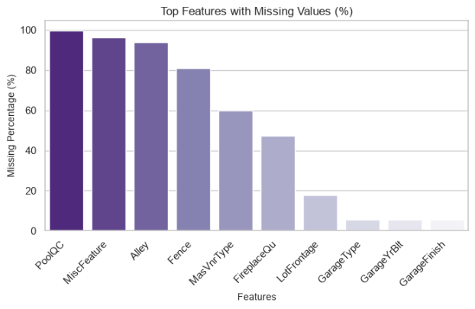

Figure 1. Missing Data Figure 2 Bar plot- Missing Data
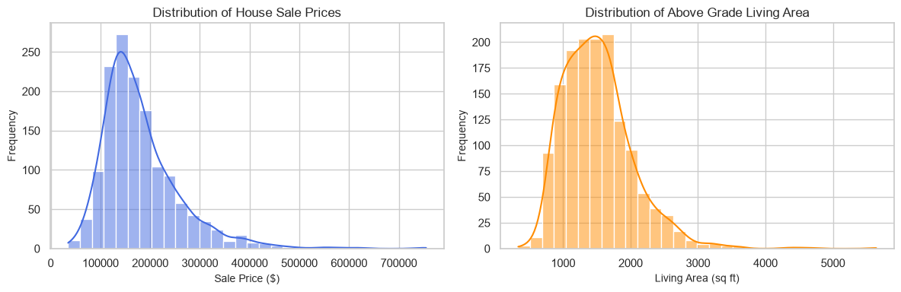
Figure 3 Histogram of KDE Curve for Sal e Price and Living Area
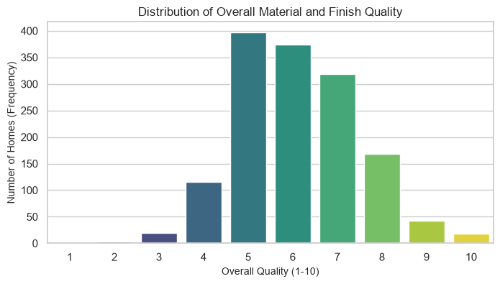
Figure 4 Count plot of frequency Distribution of Property Qualities
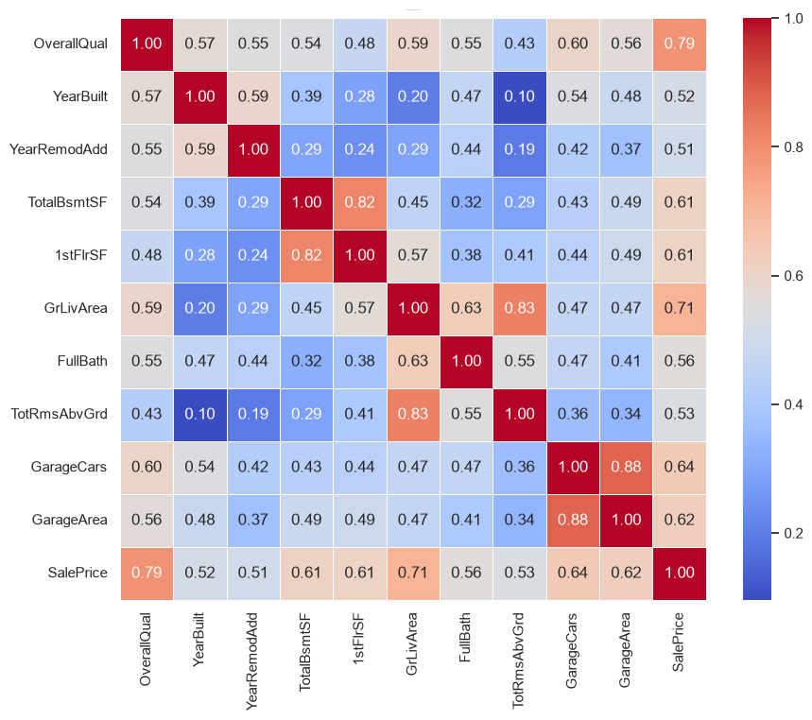
Figure 5 Correlation Matrix of numerical variables
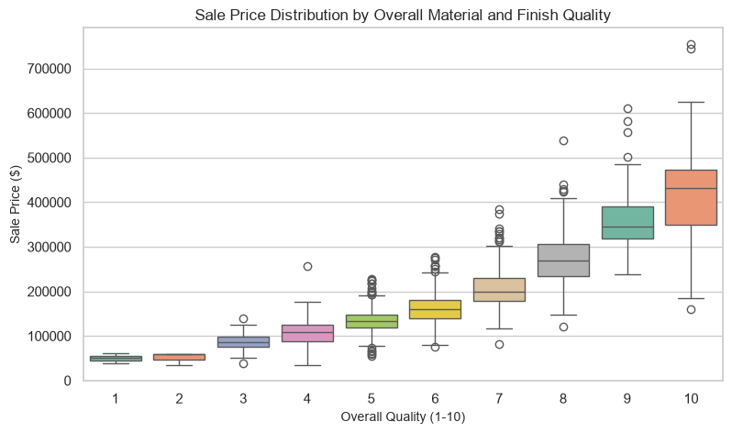
Figure 6 Box Plot of the relationship between Overall Quality and SalePrice
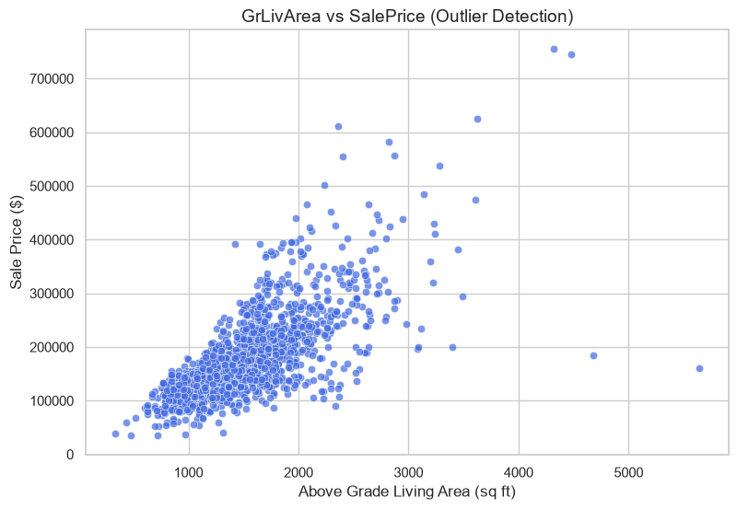
Figure 7 Scatterplot between Ground Living Area and Sale Price
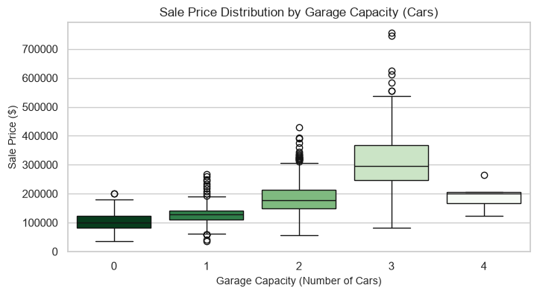
Figure 8 Box plot of Garage Capacity (Cars) and Sale Price

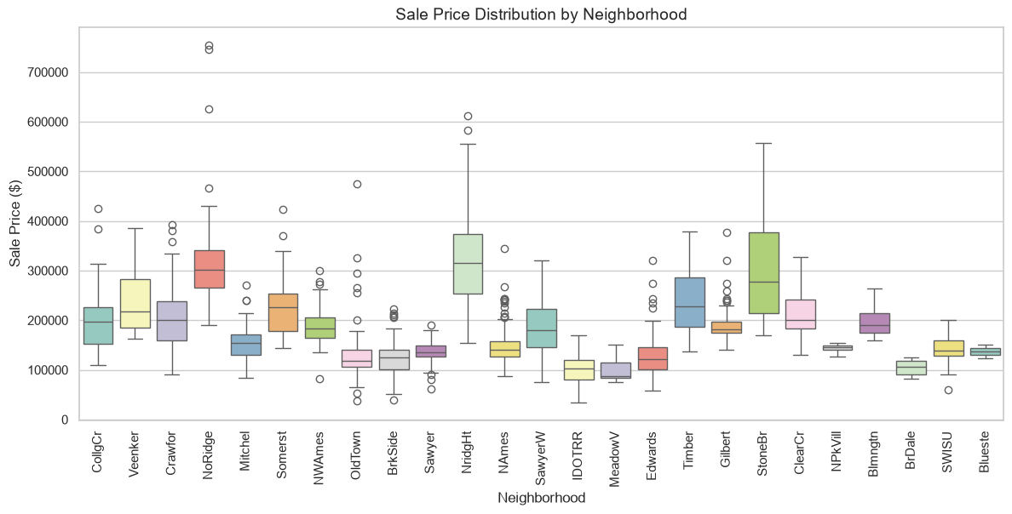
Figure 9 Box plot of distribution of the sales prices across different neighborhoods

